My LEARNING CHALLENGES and skills to practise this summer term in Year 5.
Core skills this term to catch me doing well (please send any photos or messages showing the skill at home). Children will get a sticker in their special book when they show these skills at home and / or in school.
Communication and Digital Literacy The ability to speak effectively for different audiences; to listen, to understand and respond appropriately to others; participate in group discussion; communicate using a range of media (dance, art, song, thought). Digital literacy refers to an individual's ability to find, evaluate, and compose clear information through writing and other mediums on various digital platforms. Digital literacy does not replace traditional forms of literacy, instead it builds upon them.
Enquiry and Reasoning Asking relevant questions; posing and defining problems; planning what to do; planning how to research; predicting outcomes; anticipating responses; testing ideas and conclusions; improving ideas. Giving reasons for opinions and ideas; drawing inferences and making deductions; using precise (reasoning) language to explain thinking; making judgements and decisions informed by reasons or evidence.
My Reading Challenges in school include:-
This term my home learning challenge question(s) that I have chosen myself is / are…

Please research this and send in what you have found out. Please use any form of media to answer the question(s).
Please also read regularly at home and practise your weekly spellings and times tables.
www.interactive-resources.co.uk

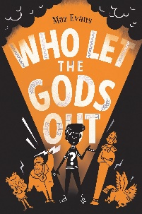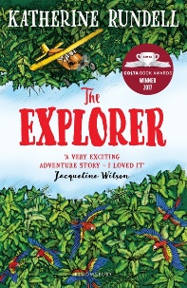
My Learning Challenges in school include:
Why are rainforests important to us all?
Where are rainforests located and what are their main features?
Why are rainforests often in the news and what can we do to help?
What can you find out about an endangered animal that lives in the rainforest?
How important is the Amazon to the South American rainforests?
Why is Brazil in the news again?
For the full curriculum map go to:www.brockwell-jun.derbyshire.sch.uk

